**ST.XAVIER,S COLLEGE**

**Maitighar, Kathmandu**



Computer Graphics Assignment #7

**To implement scaling, translation and rotation.**

Yub Raj Basnet

013BScCSIT048 (4th Semester)

**Submitted to**

|  |  |
| --- | --- |
| Er. Anil Sah  (Lecturer, St.Xavier’s College ) |  |

**Submitted date: Sept 01, 2015**

# STATEMENT

To implement scaling, translation and rotation.

# ALGORITHM:

1. Input the image or coordinate(x,y)
2. For translation



1. For rotation



1. Scaling



**Source Code**

//---------------------------------------------------------------------------

#include <vcl\vcl.h>

#pragma hdrstop

#include<math.h>

#include "Unit1.h"

//---------------------------------------------------------------------------

#pragma resource "*.dfm"

Ty *y;

//---------------------------------------------------------------------------

__fastcall Ty::Ty(TComponent* Owner)

: TForm(Owner)

{

}

//---------------------------------------------------------------------------

void __fastcall Ty::Button1Click(TObject *Sender)

{

int x,y,tx,ty;

tx=StrToInt(Edit1->Text);

ty=StrToInt(Edit2->Text);

x=Image1->Height;

y=Image1->Width;

for(int i=0;i<=x;i++)

for(int j=0;j<=y;j++)

Image2->Canvas->Pixels[i+tx][j+ty]=Image1->Canvas->Pixels[i][j];

}

//---------------------------------------------------------------------------

void __fastcall Ty::Button2Click(TObject *Sender)

{

int x,i,j,y,rot,a,b;

rot=StrToInt(Edit3->Text);

x=Image1->Height;

y=Image1->Width;

for( i=0;i<=x;i++)

{

for( j=0;j<=y;j++)

{

a=i*cos(rot)-j*sin(rot);

b=j*cos(rot)+i*sin(rot);

Image2->Canvas->Pixels[a][b]=Image1->Canvas->Pixels[i][j];

}

}

}

//---------------------------------------------------------------------------

void __fastcall Ty::scalClick(TObject *Sender)

{

int x,i,j,y,x1,y1;

x1=StrToInt(Edit4->Text);

y1=StrToInt(Edit5->Text);

x=Image1->Height;

y=Image1->Width;

for( i=0;i<=x;i++)

{

for( j=0;j<=y;j++)

{

Image2->Canvas->Pixels[i*x1][j*y1]=Image1->Canvas->Pixels[i][j];

}

}

}

//---------------------------------------------------------------------------

void __fastcall Ty::Edit2Change(TObject *Sender)

{

}

//---------------------------------------------------------------------------

# Output

Translation:

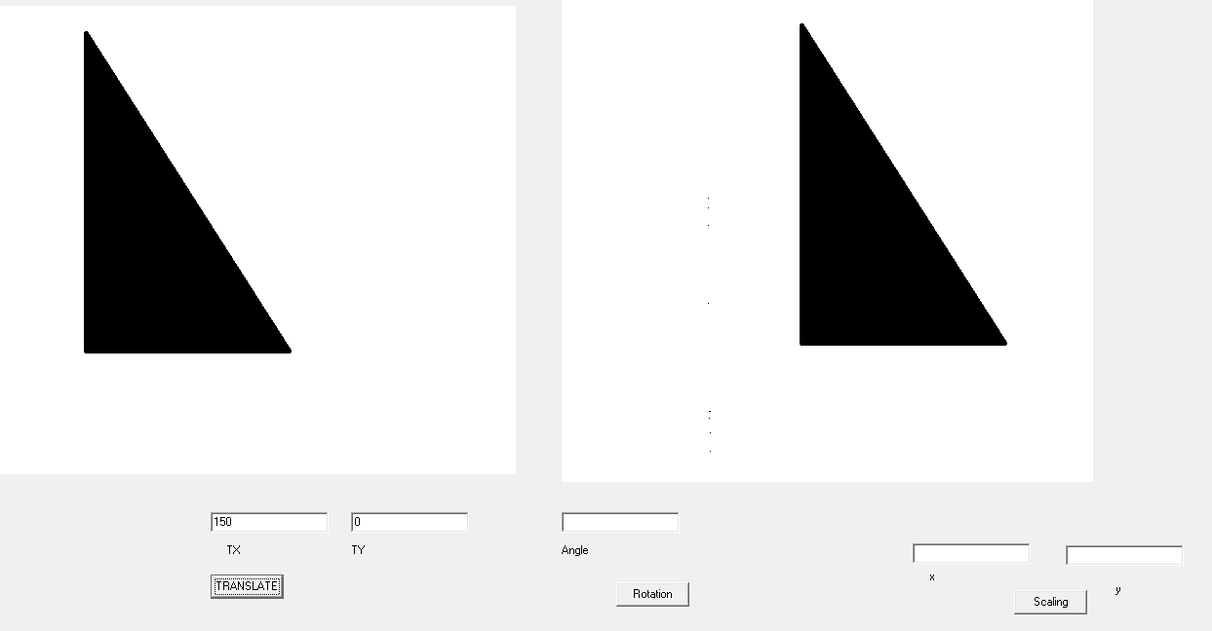

Rotation:

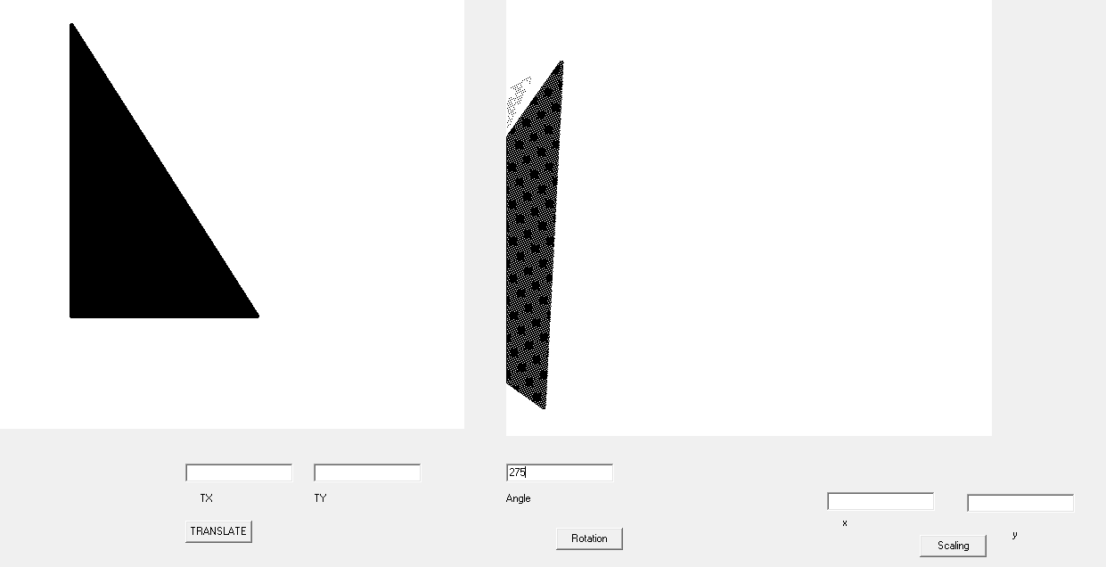

Scaling

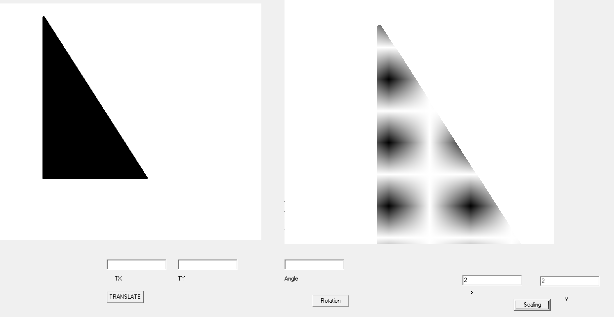

# Conclusion:

Hence, translation, rotation and scaling was implemented using C++ builder.

# Reference

https://users.soe.ucsc.edu/~pang/160/f12/slides/bla.pdf